TÜV SÜD Industrie Service GmbH · 60487 Frankfurt am Main · Deutschland
The company
Applicant and future certificate holder
Street, Number
Postcode, Town
applies for
the certification oft he property ☐ first time ☐ recurrently
according to the scheme ☐ BREEAM Neubau ☐ BREEAM Bestand in ☐ Germany ☐ Austria ☐ Switzerland
(only New Construction)
assessment type ☐ Shell Only ☐ Shell and Core ☐ fully fitted
building type: building designation (residential building, office building, industrial building, etc.)
Building name
Street, Number
Postcode, Town

at the

certification body TÜV SÜD NSO BREEAM D-A-CH

of TÜV SÜD Industrie Service GmbH
Frankfurter Straße 63-69
65760 Eschborn

As licensed assessor / auditor organization for auditing the property is assigned:

Licensed assessor / auditor organization
Lizenznummer LI-BDE-XXX
Street, Number
Postcode, Town

The above named licensed assessor / auditor organization appoints the licensed assessor / auditor name, first name, license no. to conduct the assessment.

Formal obligation
By signing the application for certification
- the certificate holder confirms
  - the commitment to comply with the requirements of the specified certification scheme
  - the commitment to provide any information needed fort he auditing and valuation process
  - the correctness of the data supplied in this application
  - the obligation to comply with the testing and certification regulations of the TÜV SÜD Group (see https://www.tuvsud.com/en/-/media/global/pdf-files/terms-and-conditions/tcr_ab1b2c6_en.pdf
- the certificate holder assigns the certification body TÜV SÜD NSO BREEAM D-A-CH to assess the conformity against the scheme requirements and to make the certification decision.
- The certification holder declares that he has not received any consulting services from the assisgned assessor / auditor organization, nor from the assigned assessor / auditor, nor from the TÜV SÜD NSO BREEAM D-A-CH with regard to the object to be certified or with regard to the structure of a management system.

Right of use
By issuing the certificate, the customer receives the right to use the TÜV SÜD BREEAM certificate and the respective TÜV SÜD certification mark, as shown below:
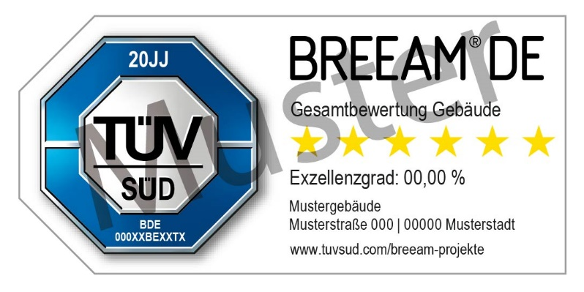
The issued certificate and the issued certification mark must not be changed, which also applies to reprints or copies.
Permission to use the certificate and the TÜV SÜD certification mark requires valid certification and applies exclusively to the property named in the certificate. The approval is limited to the certificate holder and does not include the use of the certificate and the certification mark for other areas of the certificate holder. The public, the consumer or the user of the building must not get the impression that the certificate holder as a company / organization is certified by TÜV SÜD NSO BREEAM D-A-CH. Advertising may only be carried out with the certificate and the TÜV SÜD certification mark in combination with the certified property.

The right of use for the certificate and the TÜV SÜD certification mark becomes effective after the certificate has been issued. The right to terminate the use with immediate effect comes into force if:
- the certification oft he property expires,
- the certificate or the TÜV SÜD certification mark is used in any manner contrary to the contract, abusive or misleading,
- the fee is not paid within the set time limit.

If the right of use expires, the certificate holder is prohibited from any further use of the certificate and the TÜV SÜD certification mark. Any advertising material bearing the TÜV SÜD certification mark is to be destroyed immediately or made unrecognizable.

User fee
The fees for the conformity assessment, certification decision, issuance of the certificate and use of the certificate as well as the TÜV SÜD certification mark, are to be paid to TÜV SÜD Industrie Service GmbH by the future certificate holder / certificate applicant upon registration.

Applicant and future certificate holder (company):
Klicken oder tippen Sie hier, um Text einzugeben.
Name of the signing person:
Klicken oder tippen Sie hier, um Text einzugeben.
Function of the signing person:
Klicken oder tippen Sie hier, um Text einzugeben.
certificate holder
Place, Date, Signature

